You can access the production instance of TestTrack via the web. This could be easier if you do not have the client installed on your machine. Keep in mind if you need to add a customer you will need to do so from the desktop client.

Below you will find instructions for searching for existing feature requests, adding to existing feature requests, and creating new feature requests in TestTrack Web.

1. Go to the following URL: <http://camelot.seapine.com/ttweb/>
2. Login
3. Select ‘TestTrack Bugs’ from the project dropdown

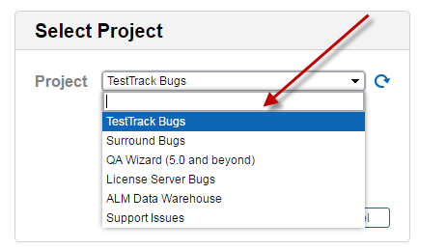

1. Click ‘Connect’
2. Click ‘Defect Tracking’ on the left panel

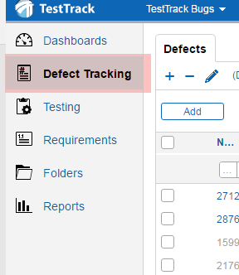

To search for existing feature requests:

1. Make sure the list window is set to ‘not filtered’

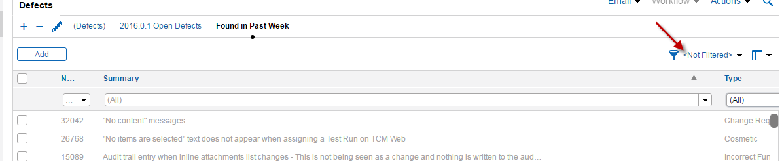

1. Select ‘Feature Requests’ from the ‘Type’ dropdown to narrow your search to only return

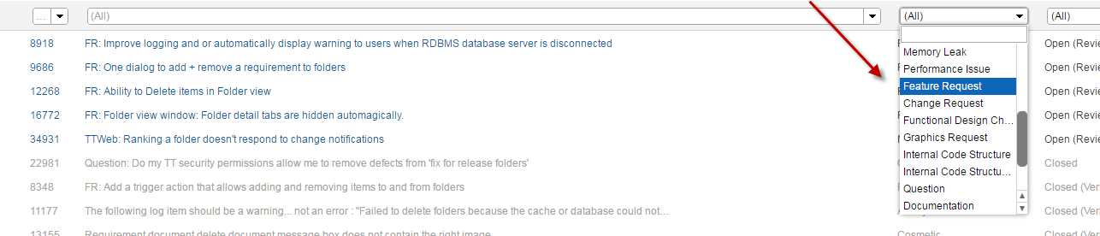

1. In the web version the closest you can do to an all text search is a search of the description and summary fields. To do this click the magnifying glass at the top right of the browser window  
   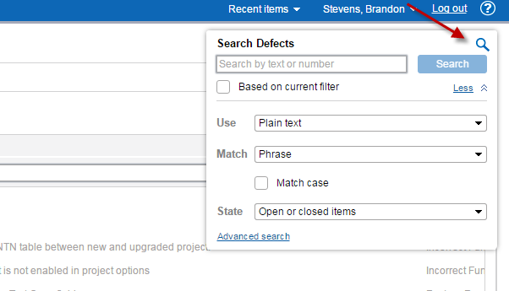

Here you will be able to type in descriptive words to narrow your search. I suggest filtering the list with 1-2 words at a time.

1. As your search narrows, you can read and/or click on the summaries to view the description of the issue to see if it matches what you are searching for. If does…
   1. Click the ‘edit’ button on the bottom right portion of the screen

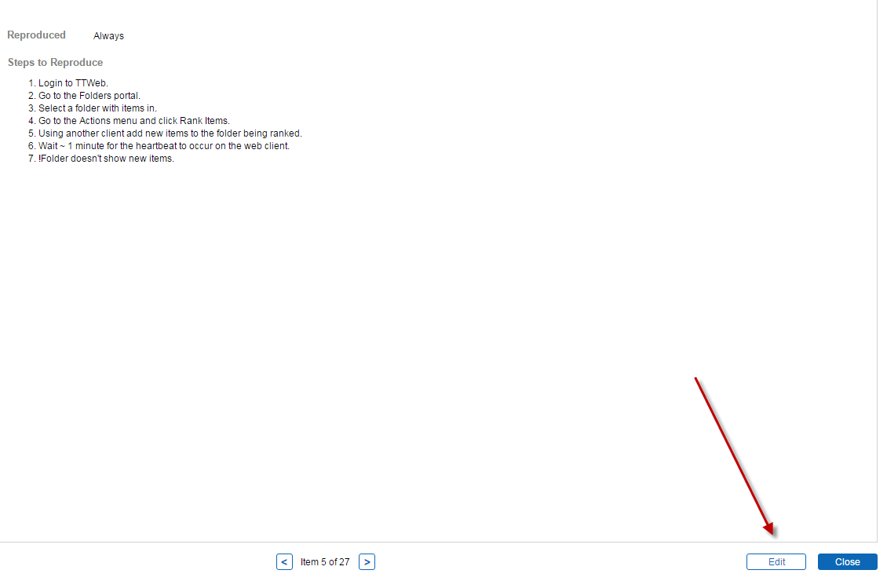

* 1. Then click ‘add’

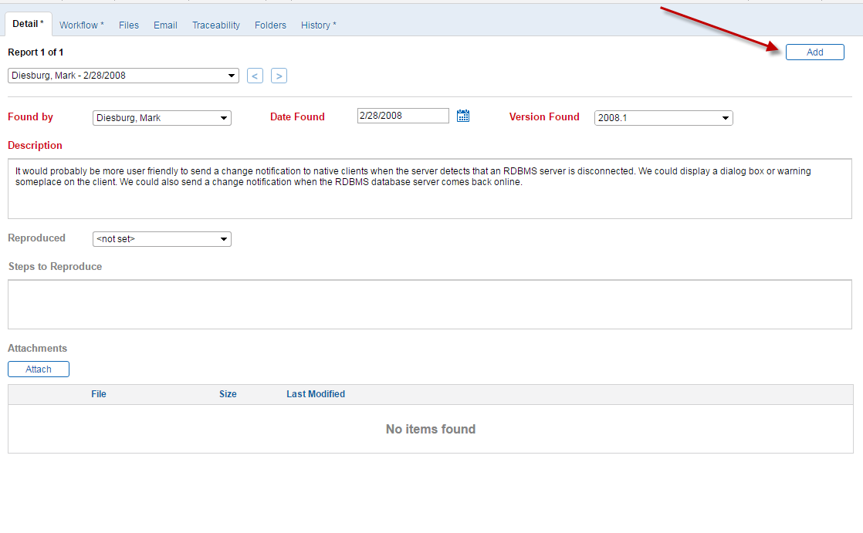

* 1. Click the ‘Found by’ drop down box and begin typing the customer’s name. **\*\*\*If you do not find the customer you will need to add them to the customer list which cannot be done in the web client\*\*\***Select the customer name once you have found it.
  2. Fill in the description with what the customer is requesting. Most times, we just copy/paste emails directly from the customer that explains what feature they want and how it will benefit their business needs. It is also important to add the case number, ‘Version Found’, and the ‘Feature’ (which is usually set to ‘Not a Bug’)
  3. Support Case # - enter the case number
  4. Version Found – this will always be the current version of the product since we do not add features to older versions

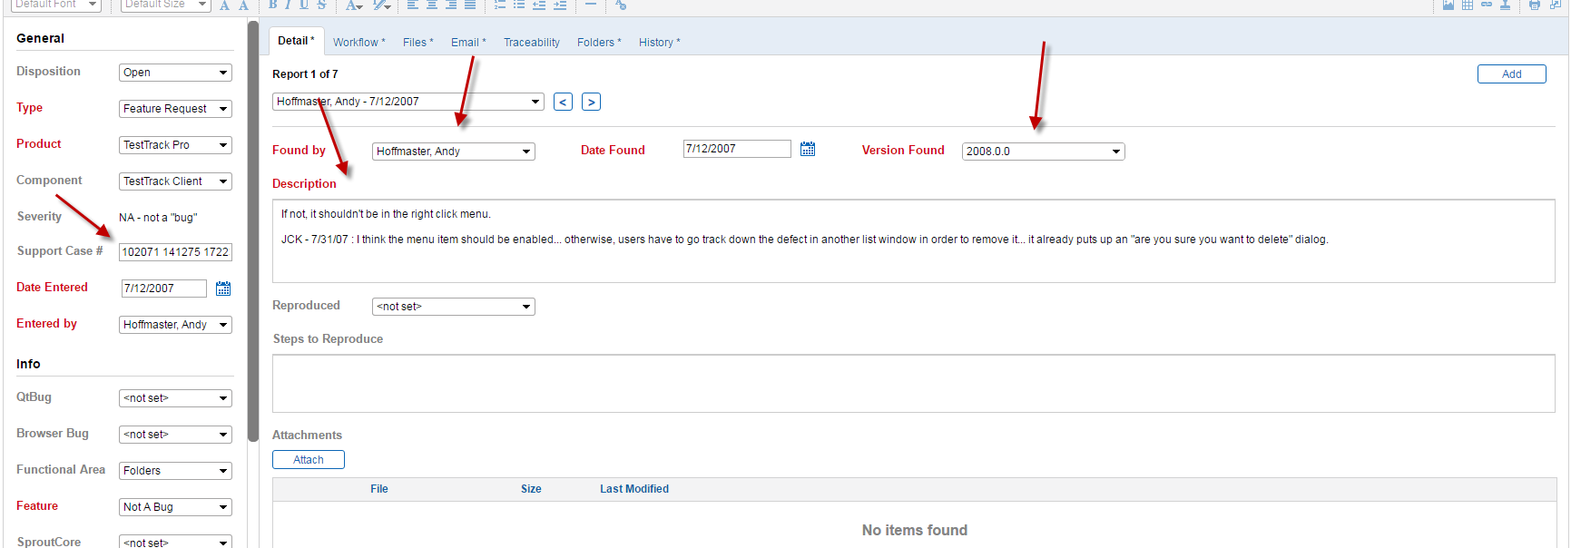

* 1. Save the changes you made and copy the URL from the address bar into save in your case notes

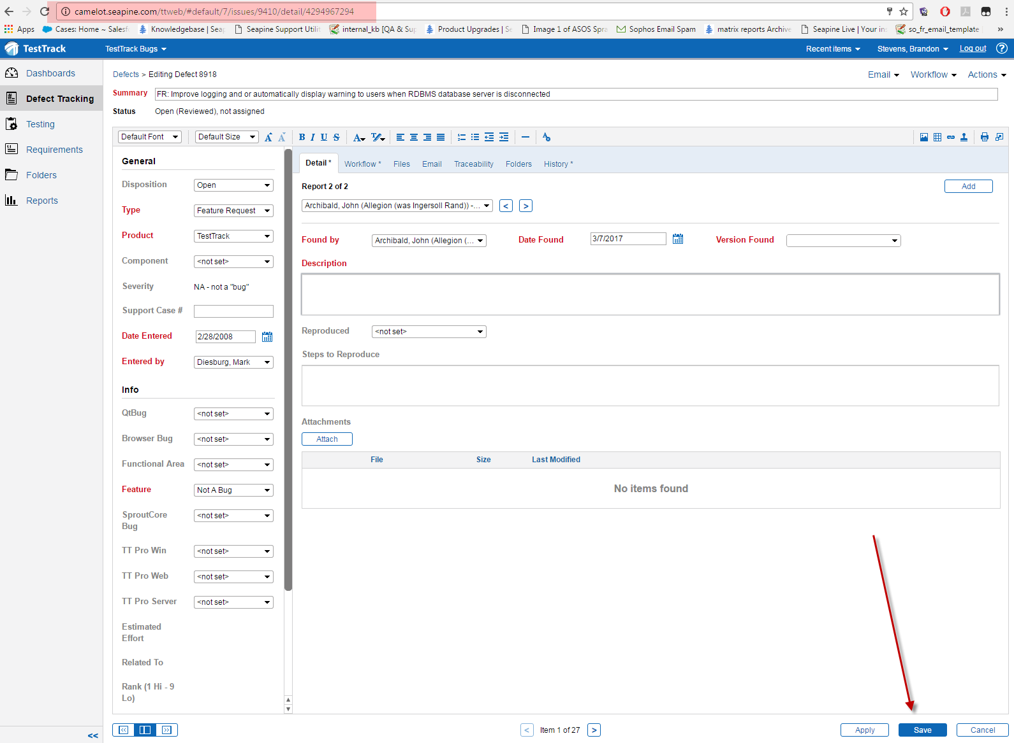

If you have searched for a feature request but have not found anything that matches your search, you can create a new feature request. To do so:

1. From the ‘Defect Tracking’ list window click the ‘Add’ button

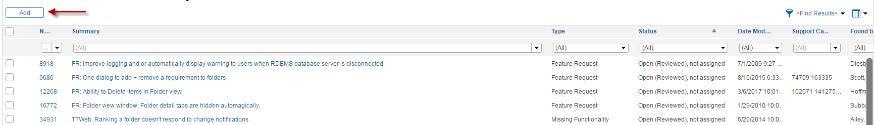

1. Fill in the fields in red.
   1. Summary
   2. Type – ‘Feature Request’
   3. Product
   4. Feature –‘Not a Bug’
   5. Description – copy/paste email from customer
   6. Version Found – This will always be the
   7. Support Case # - not in red but important to also include

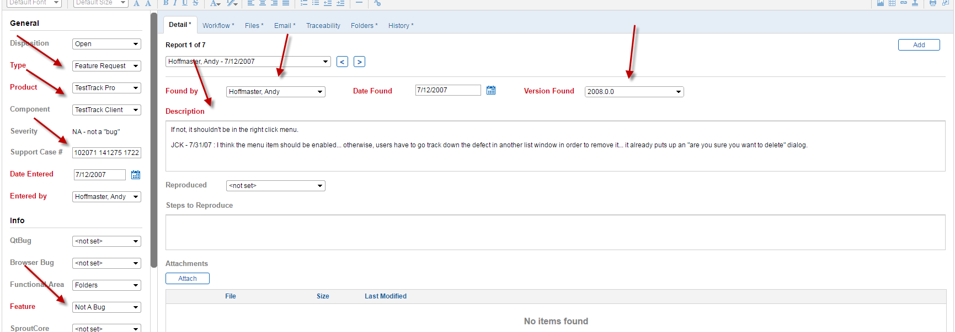

1. Save the changes and copy the URL in the browser address bar to save in your case notes

